Tenda AC5-How to setup PPTP, L2TP
Model Number: Tenda AC5
Question Classification: Function Setting

Step 1: Open a browser and type tendawifi.com in Address Bar, tap “Enter”. Input login password and tap “Login”.

Step 2: Tap “VPN”. and choose “PPTP/L2TP Client”.
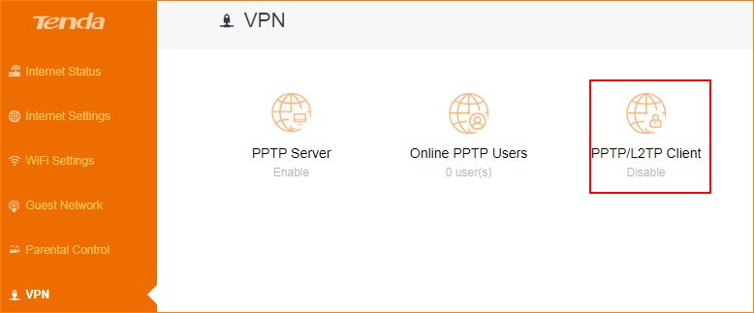

Step 3: Enter correct VPN information and tap “Connect”.

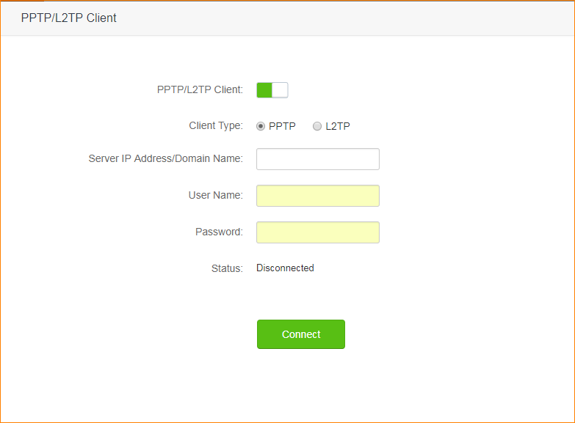

Step 4: If connect successfully, you can see “Connected” in connection status.

